MINISTRY OF EDUCATION AND SCIENCE OF UKRAINE NATIONAL TECHNICAL UNIVERSITY “KHARKIV POLYTECHNIC INSTITUTE”

DEPARTMENT OF SOFTWARE ENGINEERING AND MANAGEMENT INFORMATION TECHNOLOGY

REPORT

on laboratory work 1 __

on the discipline

“PYTHON FRAMEWORKS”

EXECUTED BY

Student of the group KN-218.ia

CHUKWU IRELE

CHECKED BY

Assoc. prof. of department “SEMIT”

PhD assoc. prof.

SVETLANA Kovlenko

Z

Kharkiv 2020

**Objectives**

1 Learning the specifics of using Python language in Jupyter Notebook.

**Tasks**

1. Install Anaconda.
2. Create environment for Python 3.
3. Change the Jupyter start-up folder.

1. Using the Markdown language and HTML tags for the country, according to you individual task (see Table 1), input information about the country’s area, its population, government, celebrities, cultural and natural attractions, and so on. When formatting information, you should use:

˗ headings of different levels; ˗ bold, italics and underlines;

˗ different colors of symbols and background; ˗ borders;

˗ tables;

˗ nested lists;

˗ linked and embedded pictures; ˗ hyperlinks;

˗ the HTML tag <svg> to draw the country’s flag.

1. Create a function to implement the algorithm, according to your individual task from Table.

        1. For the created function implement 2-3 test cases in the cells of the Jupyter notebook. For all tasks, organize checking of the input values, for example, as follows:

**Progress of work**

* 1. Install Anaconda AND Create environment for Python 3

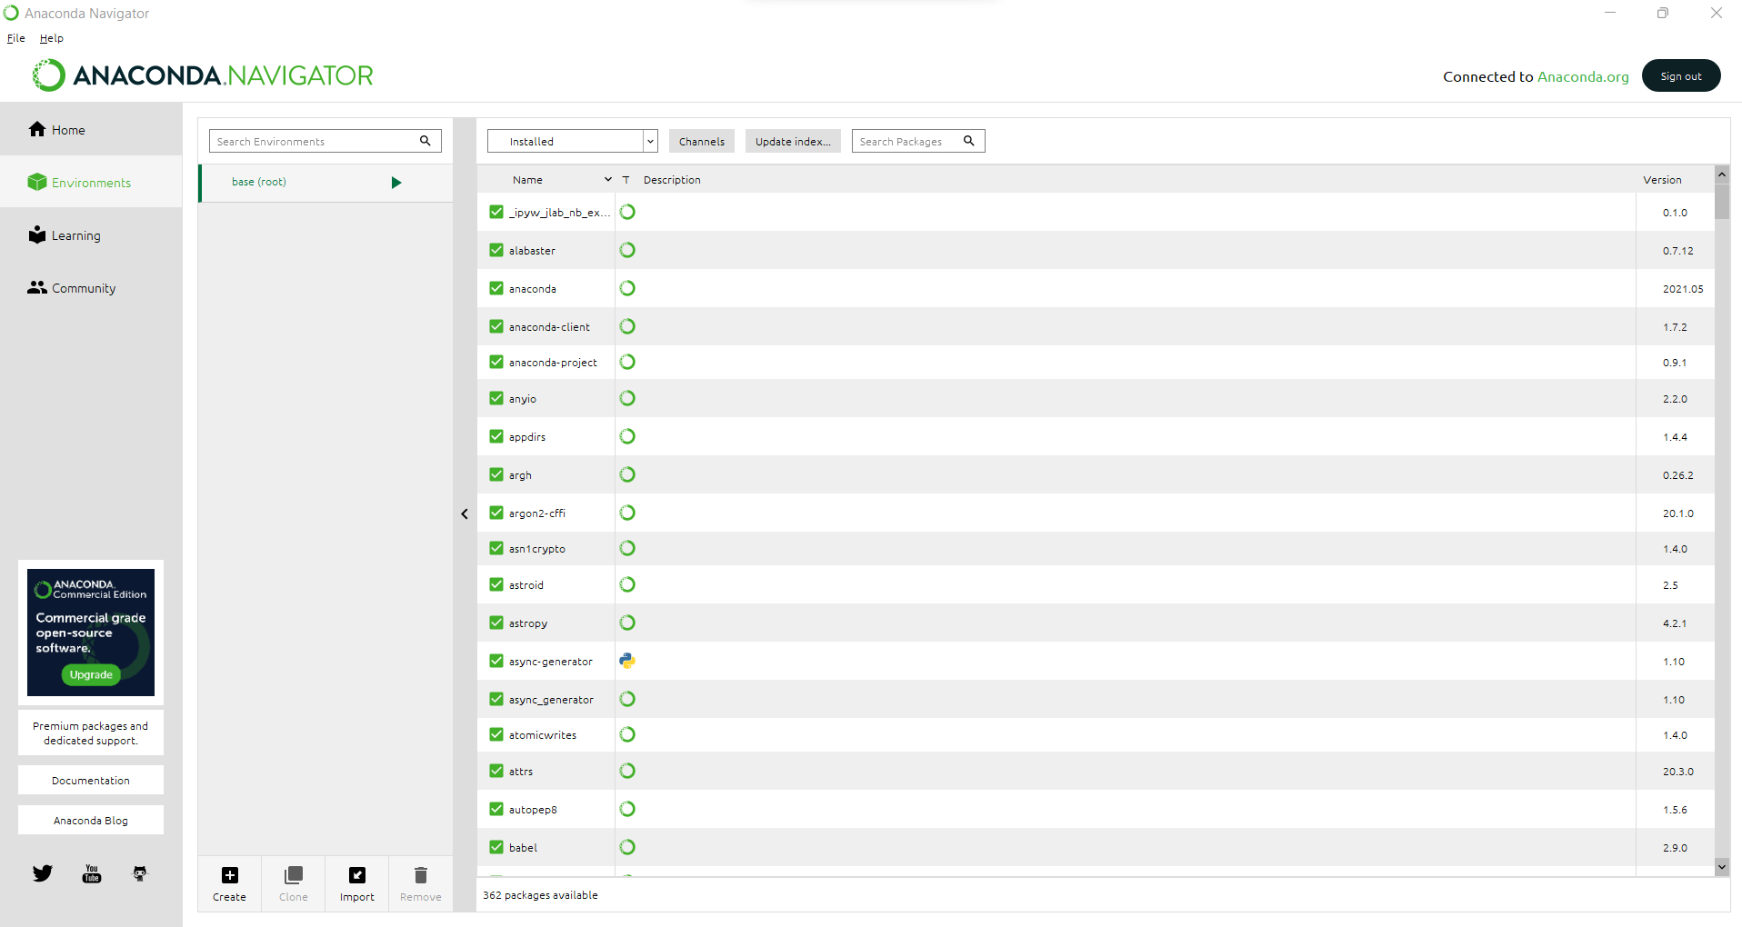

* 1. Change the Jupyter start-up folder

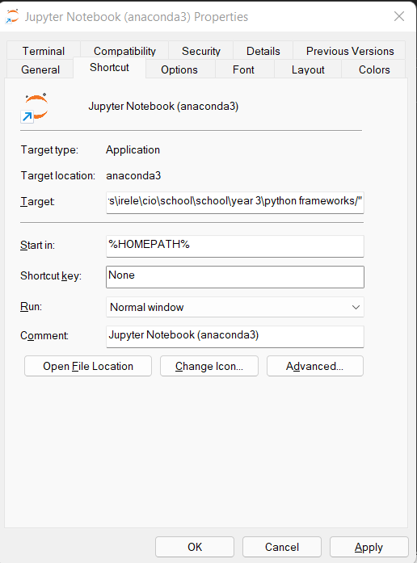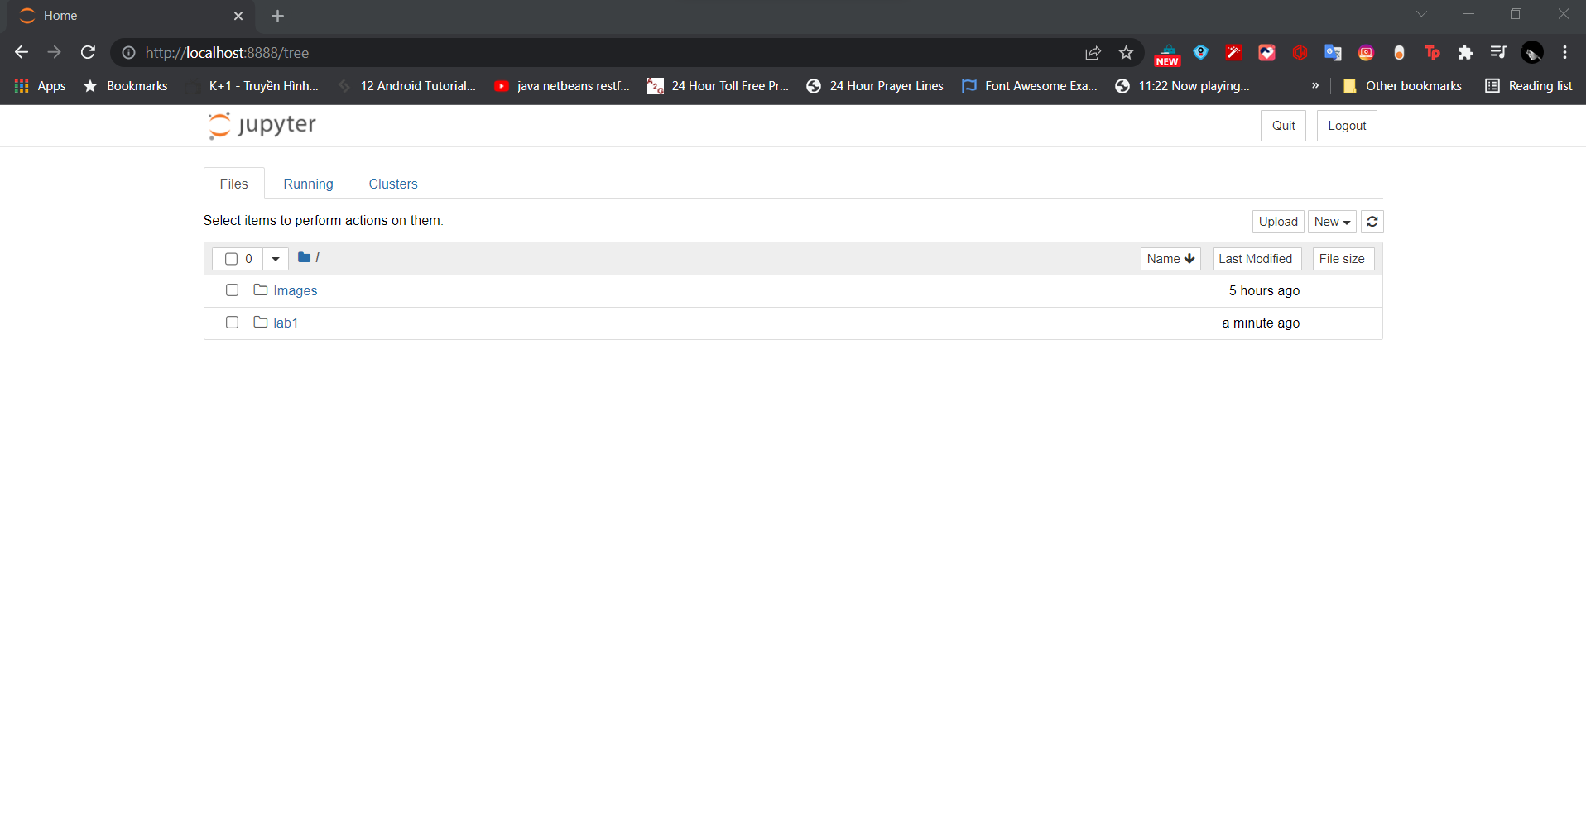

* 1. Using the Markdown language and HTML tags for the country, according to you individual task (see Table 1)

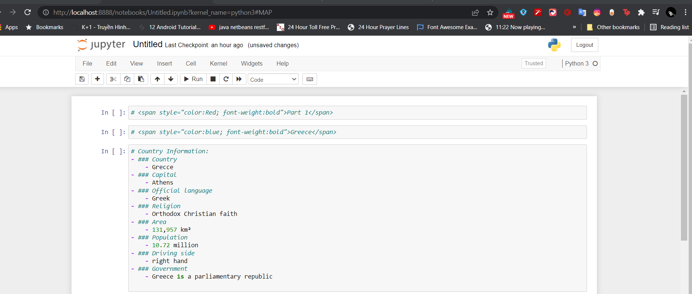

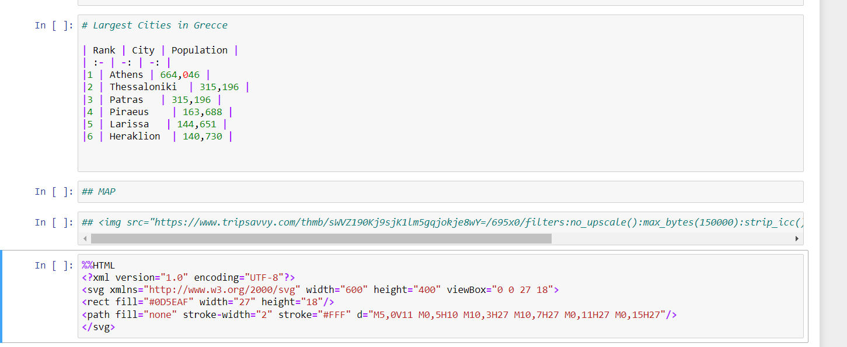

Result of Part 1

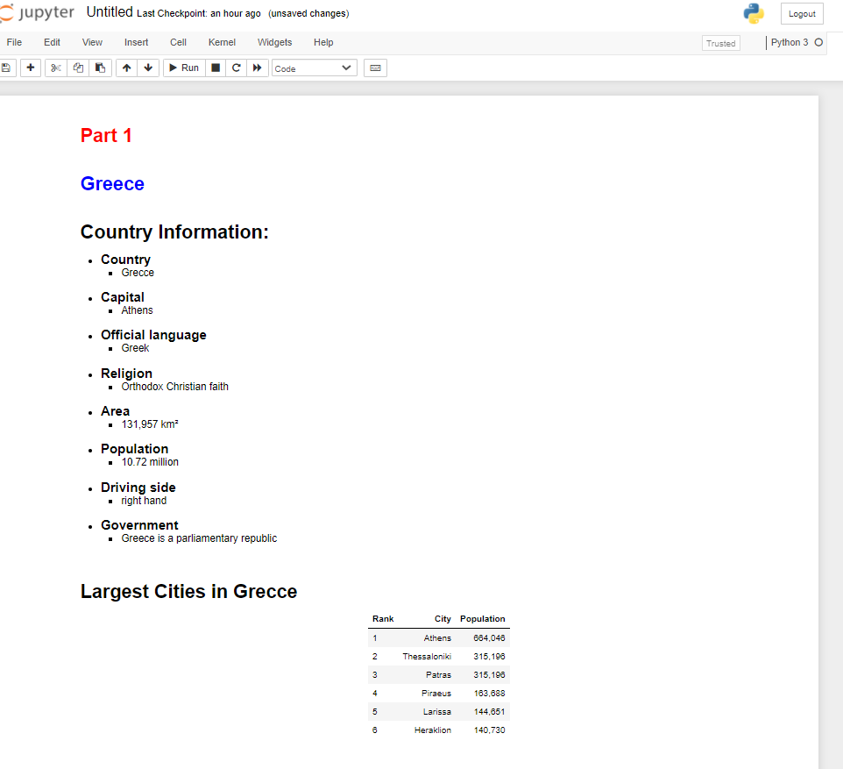

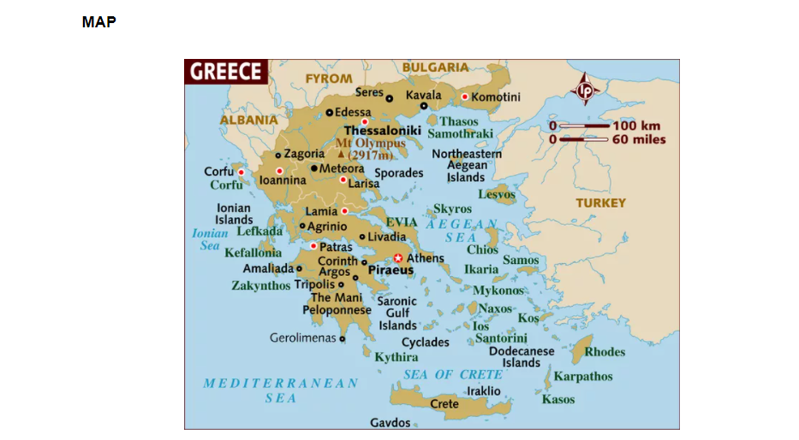

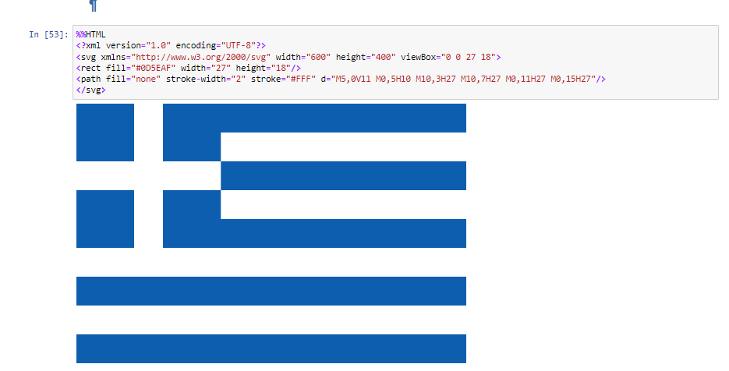

* 1. Create a function to implement the algorithm, according to your individual task

from Table. 1. For the created function implement 2-3 test cases in the cells of the

Jupyter notebook. For all tasks, organize checking of the input values, for example,

as follows:

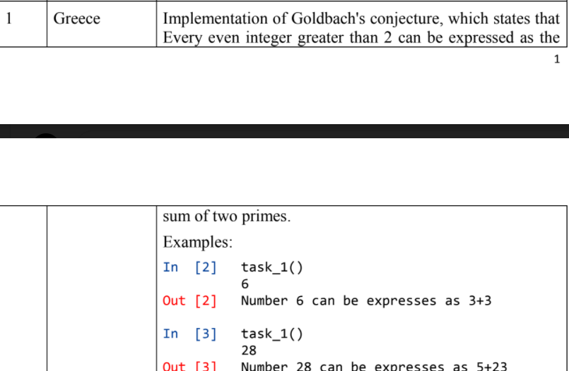

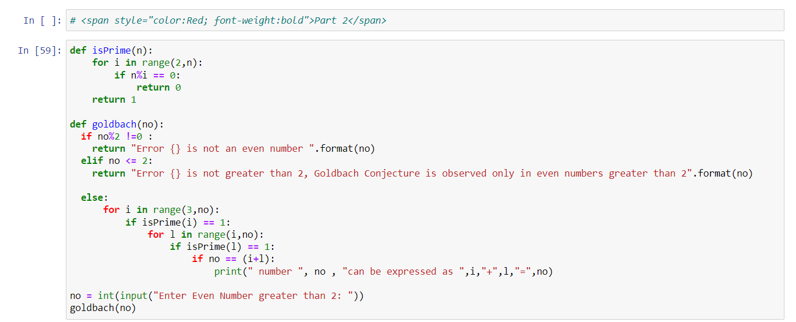

Result of part two :

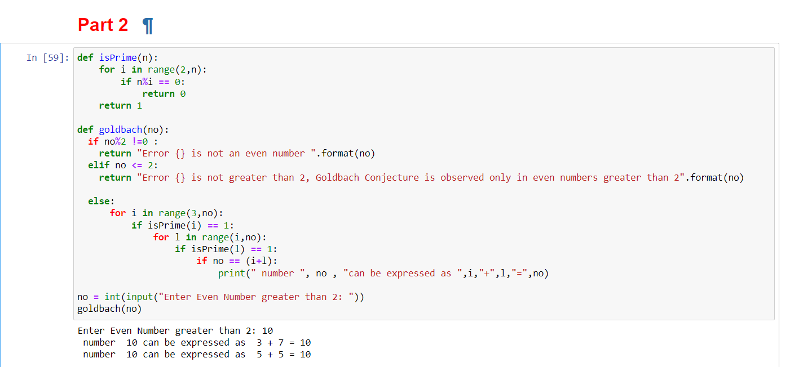

Link to git.hub file :

https://github.com/irele/school/blob/master/school/year%203/python%20frameworks/Untitled.ipynb